These are the TV listings for London from 6:00 pm to 9:00 pm for a Saturday night (not this Saturday). Read them and then answer the questions on the other side. It’s not difficult but remember this is a scan reading exercise so it’s more a question of speed. First person to finish wins a weekend trip to The Sphinx (if you pay for it and arrange it).

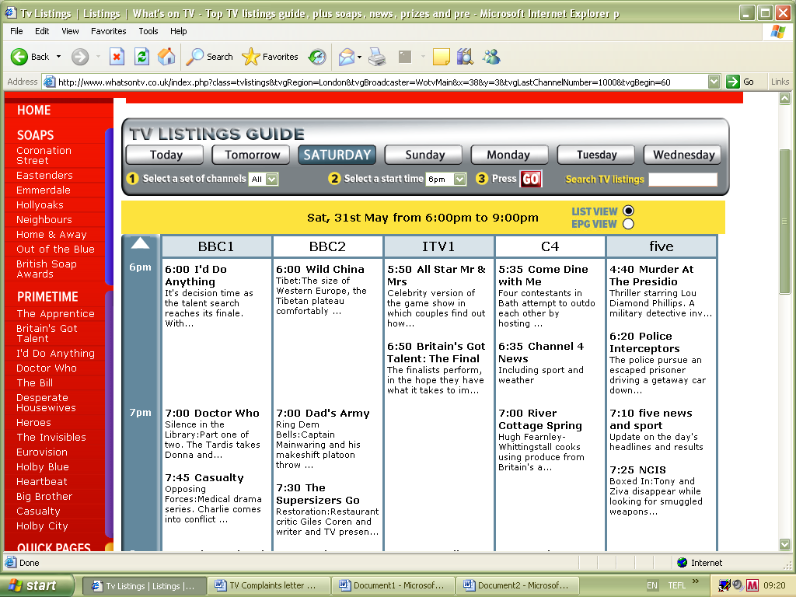
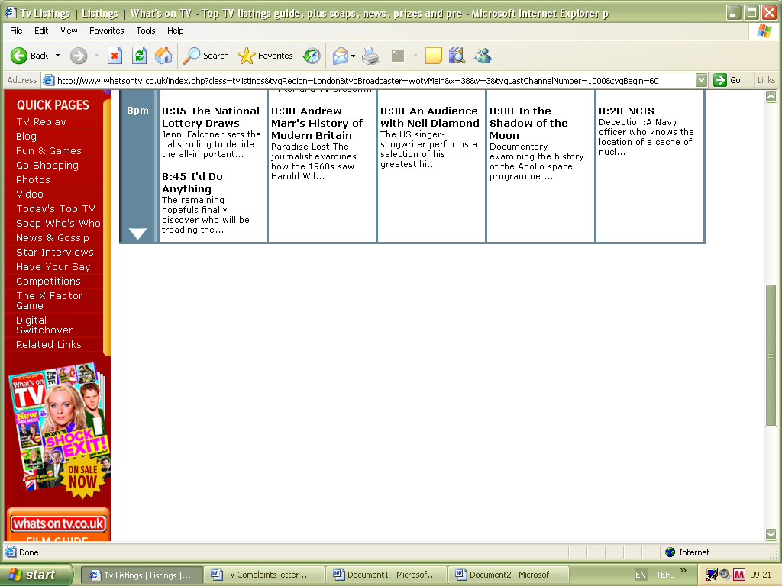

Now answer these questions:

- Which two programmes are trying to find people with interesting abilities?

- What’s the name for this type of programme?

- What is the name of the celebrity game show?

- What time can you learn if you have won lots of money?

- Which show is set in a hospital?

- What channel is the cookery programme on?

- Which programme will be about a disagreement between a man and somebody else?

- What type of programme is on Channel Five at 6:20 pm?

- And what time can you learn about astronauts?

And now some personal opinion questions:

- Which channel is the most interesting, and why?

- Which programme would you like to watch, and why?

- Which channel wouldn’t you like to watch on Saturday, and why?

- Which of these programmes can you see in your country?

- Do you think from these listings that English TV is generally decent or totally awful?

